
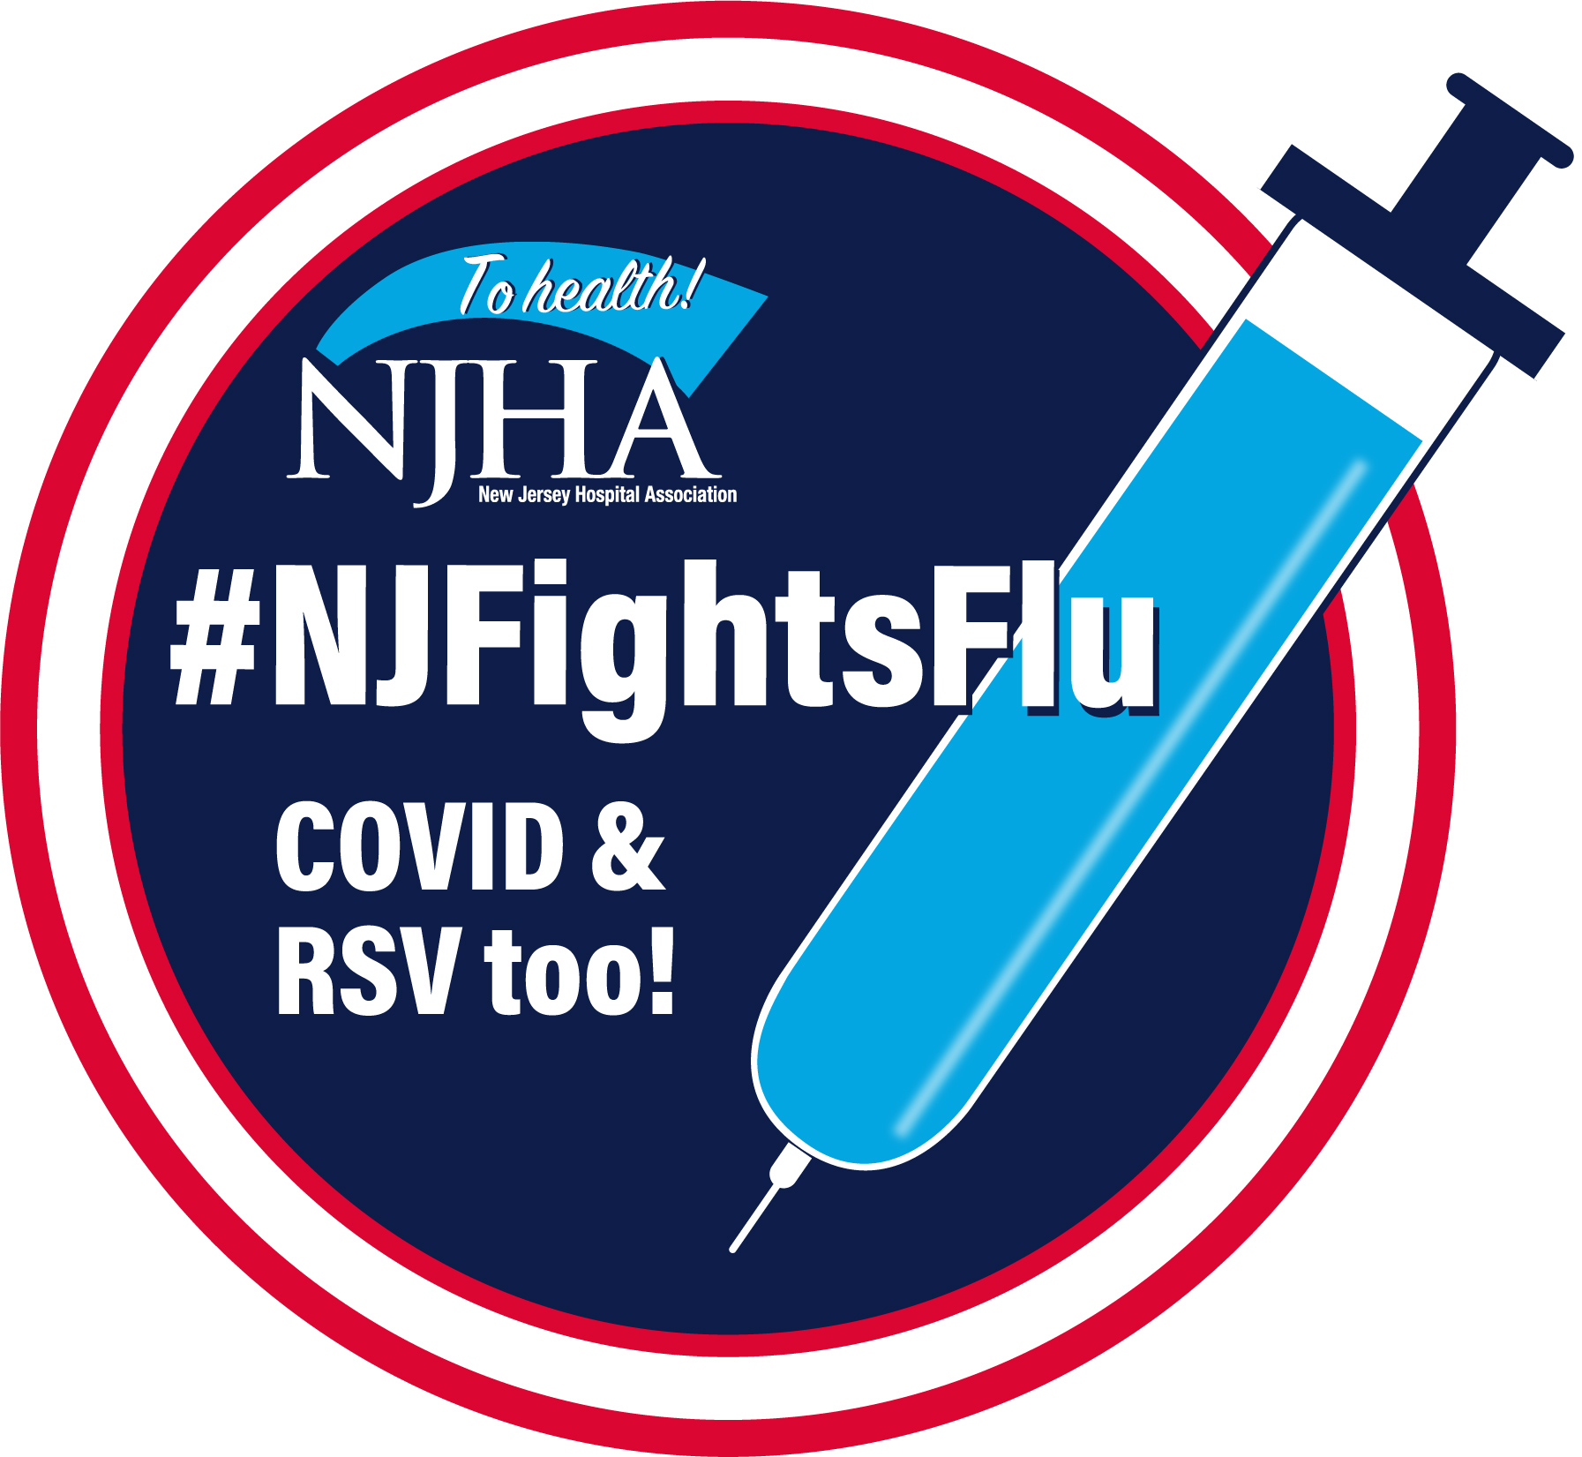

N.J. Flu Vaccination Law for Healthcare Workers
Talking Points | 2025-2026 Flu Season

New Jersey law requires employees in hospitals, nursing homes, home health agencies and potentially other facilities indicated under N.J. Department of Health guidance to implement a mandatory flu vaccination program for all employees. Find the law here.
The following talking points may be used with employees, community members, the media or other stakeholders to discuss the law, its requirements and its importance in protecting the health of staff, patients and residents, and our communities.
Talking Points
- Gov. Murphy signed a law in January 2021 requiring healthcare workers to get a seasonal flu vaccination.
- The flu vaccine is more important than ever to protect ourselves from preventable illnesses like the
flu – especially with the triple threat of COVID-19 and RSV.
- This flu season, the flu shot along with the updated COVID-19 vaccine provides maximum protection for healthcare workers, their patients and their loved ones at home. The two vaccines can be administered safely at the same time.
- In addition, for the first time an RSV vaccine is available for older adults, infants and pregnant women to provide further protection.
- The state law requires all employees to get a flu vaccine within hospitals, nursing homes, home health agencies and potentially additional sites designated by the N.J. Department of Health. That includes everyone, even if they are not directly involved in providing healthcare services.
- The only exceptions are for those individuals who have a valid medical reason that they cannot receive
the vaccine. Those individuals will have to complete a state form to validate the medical exemption.
- We are making the flu vaccine available to our employees in as convenient a fashion as possible.
- Employees also have the option of getting the flu vaccine on their own, but they must provide documentation of the vaccination here to the organization.
- As an organization, we must report to the state our overall employee vaccination rate, and also documentation of the employees who qualify for a medical exemption.
- We also are required to provide an educational component to employees.
- This is one in a long list of safety precautions we have taken to protect our patients/residents from
the spread of viral illnesses.

