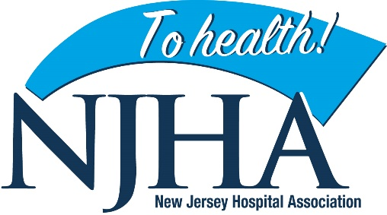
#HealthyHolidaysNJ Social Media Toolkit
These ready-made sample posts can be used in conjunction with social media graphics provided by NJHA.
Recipe for a Healthy Holiday
Sample Content:
Gathering with family and friends is a time-honored holiday tradition, but don’t invite viral illnesses to your celebrations. Make sure you’re all following the recipe for #HealthyHolidaysNJ.
The holiday season is prime time for viral illnesses to spread. With high levels of flu, continuing cases of COVID and other illnesses circulating, please follow our recipe for #HealthyHolidaysNJ.

Happy Thanksgiving! As you gather with family and friends, take these precautions to prevent illness and ensure that everyone enjoys #HealthyHolidaysNJ.

Don’t let illness sideline you from the feasting, football and family fun this Thanksgiving. Make sure you’re all following the recipe for #HealthyHolidaysNJ.

A healthy holiday seasons begins with an ounce of prevention and a pinch of preparation. Follow this recipe for #HealthyHolidaysNJ.
- Get a flu shot
- Stay up to date with your COVID boosters
- Stay home if you’re sick
- Wash your hands frequently
- Cover your coughs and sneezes
- Take extra precautions around elders or those with compromised immune systems.

A Healthy Conversation
Sample content:
Nov. 24 is #FamilyHealthHistoryDay. As you gather to give thanks, make time to talk about health issues that may run in your family. It’s part of your family’s story and knowing any family health risks could help protect those in generations to come. #HealthyHolidaysNJ
This Thanksgiving, take some time to talk with relatives about health issues that run in your family. Understanding your family health history gives you the power to protect your health through screening and early detection tests. #HealthyHolidaysNJ
Each year, Thanksgiving coincides with #FamilyHealthHistory Day. As you gather to give thanks, make time to talk with loved ones about health issues that may run in your family. This short guide can help you start the conversation with important questions to ask.
Each year, Thanksgiving coincides with #FamilyHealthHistoryDay – a time for family conversations on health risks that run in your family. Understanding your risks of conditions like heart disease or certain cancers can help you take precautions and get health screenings to protect your health. You’ll be thankful to know. #HealthyHolidaysNJ https://www.cdc.gov/genomics/famhistory/knowing_not_enough.htm
Nov. 24 is #FamilyHealthHistoryDay. As you gather to give thanks, make some time to talk about health issues that may run in your family. And once you have this important family information, ask your physician or nurse about your potential risks and whether there are screening tests to help you detect them early. You’ll be thankful you did. #HealthyHolidaysNJ https://www.cdc.gov/genomics/famhistory/knowing_not_enough.htm
Are You Up to Date?
Sample content:
Getting sick over the holidays? That’s not cool. COVID booster shots have been updated to provide even better protection against new variants. Get boosted now and be ready for all the holiday food, fun and festivities. #HealthyHolidaysNJ
If it’s been more than 2 months since your last COVID shot, you might be out of date. The new & improved COVID boosters protect against new COVID variants. Get it now from your healthcare provider or local pharmacy to provide protection for the fall and winter. #HealthyHolidaysNJ
Those old COVID booster shots? That’s so last year. The new and improved booster shots protect against new variants. If it’s been more than 2 months since your last COVID shot, you’re due for an update. Get it now from your healthcare provider or local pharmacy to provide protection for the fall and winter. #HealthyHolidaysNJ
Just like tech and fashion, COVID booster shots can go out of date. The new and improved booster shots protect against new variants. If it’s been more than 2 months since your last COVID shot, you’re due for an update. Get it now from your healthcare provider or local pharmacy to provide protection for the fall and winter. #HealthyHolidaysNJ #COVID #COVIDvaccination #COVIDbooster

