Get Vaccinated/Get Boosted
Social Media Toolkit for the Holiday Season

NJHA has developed this social media toolkit to promote COVID vaccination and booster shots this holiday season. With emerging variants, waning protection from the initial course of vaccination and holiday gatherings, the next several weeks will be critical for determining the course of COVID in New Jersey this winter. Please feel free to use these graphics and sample messages in your efforts to promote vaccination among patients, residents, staff and community members.
All graphic materials can be downloaded at www.njha.com/covid-bigshot/downloads. Contact Kerry McKean Kelly at kmckean@njha.com, 609-275-4069, or Pam Brown Villaruz at pvillaruz@njha.com,
609-275-4068, with any questions.

Twitter
- The COVID vaccine & booster shot can deliver the most precious of gifts – good health. They’re safe, free and provide effective protection against serious illness and hospitalization. Get your shot today and be protected for Christmas and New Year’s celebrations.

- Show you care by getting the COVID booster shot. It provides continued protection and is recommended if you’re 18 or older and it’s been more than 6 months since you received the Pfizer or Moderna vaccines or 2 months since the Johnson & Johnson vaccine.

- If it’s been a while since you got your COVID vaccine, you may not be fully protected. Boosters are needed if you’re 18+ and it’s been 6 months since you got the Pfizer/Moderna shots or 2 months since the Johnson & Johnson shot. Get boosted now and stay protected.

- Don’t take a chance with COVID variants. The COVID vaccine & booster shot provide effective protection against serious illness and hospitalization. Get the shot now to protect yourself and those around you this holiday season. Covid19.nj.gov/vaccine

Facebook/Instagram
- The COVID vaccine and booster shot can deliver the most precious of gifts – good health. They provide very effective protection against serious illness and hospitalization. Now is the time to get vaccinated – or get the booster shot – and ensure you’re protected for Christmas gatherings or New Year’s celebrations. Vaccines and booster shots are safe, free and readily available at hospitals, pharmacies and other locations across your community. Or, go to covid19.nj.gov/vaccine for help finding an appointment.

- Show you care this holiday season by getting the COVID booster shot. It’s recommended if you’re 18 or older and it’s been more than 6 months since you received the Pfizer or Moderna vaccines or 2 months since the Johnson & Johnson vaccine. The protection provided by your initial course of vaccination declines over time, so the booster shot is important to protect yourself and those around you.

- So you’ve been vaccinated? Great! But you may not be fully protected if it’s been a while since you were first vaccinated. Booster shots are recommended if you’re 18 or older and it’s been more than 6 months since you received the Pfizer or Moderna vaccines or 2 months since the Johnson & Johnson vaccine. Get boosted now and be protected for Christmas gatherings or New Year’s celebrations. Boosters are available from your healthcare provider, local pharmacies and 1000s of other locations. Find a location at Covid19.nj.gov/vaccine

- Don’t take chances with COVID variants. The COVID vaccine and booster shot provide effective protection against serious illness and death. Get the shot now to protect yourself, family and friends for holiday gatherings. It’s free, and appointments are available at hospitals, pharmacies and vaccination sites across the state. Find a location at Covid19.nj.gov/vaccine.

- Your best shot for good health in 2022?
- Get vaccinated. The vaccine is safe, effective and recommended for ages 5 and up. It’s also free and available at thousands of vaccination sites. (Find a location at Covid19.nj.gov/vaccine.)
- Boost your protection. If you’re 18 or older and it’s been 6 months since you received the Pfizer or Moderna vaccines or 2 months since the Johnson & Johnson vaccine, it’s time for a booster shot.
- Follow the tried-and-true personal precautions like wearing a face mask, washing your hands and practicing social distancing.
- Get a flu shot. You can safely combine the flu shot with your COVID vaccine or booster shot to improve your protection this winter.
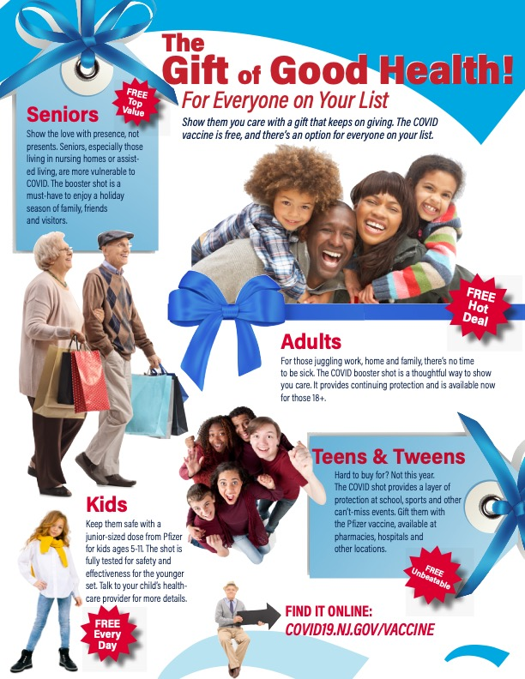
8.5x11 Flyer and Social Media Graphics
These graphics, also available in additional sizes, can be downloaded at www.njha.com/covid-bigshot/downloads.

