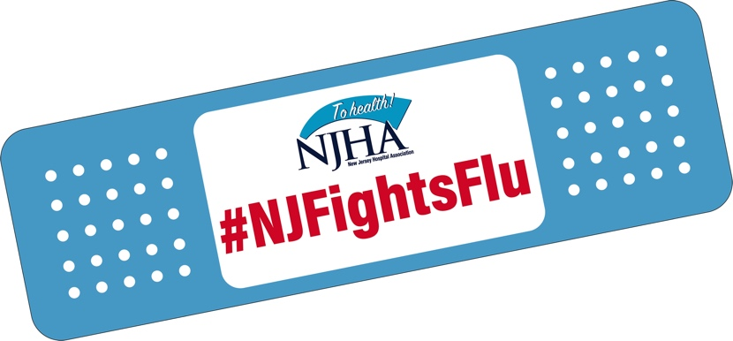

N.J. Flu Vaccination Law for Healthcare Workers
Talking Points | September 2021

N
ew Jersey law requires employees in hospitals, nursing homes, home health agencies and potentially other facilities indicated under N.J. Department of Health guidance to implement a mandatory flu vaccination program for all employees. Find the law here.
The following talking points may be used with employees, community members, the media or other stakeholders to discuss the law, its requirements and its importance in protecting the health of staff, patients and residents, and our communities.
Talking Points
- Gov. Murphy signed a law last January requiring healthcare workers to get a seasonal flu vaccination. This flu season will be the first since that law was enacted.
- It comes at a very important time, as we face the “twindemic” of COVID-19 and influenza. It’s more important than ever that we take steps to protect ourselves from preventable illnesses like the flu.
- That includes healthcare workers. The flu vaccine helps protect them, their patients and
their loved ones at home.
- It’s also important to prevent our healthcare system – including our healthcare heroes on the frontlines – from becoming overburdened if we see a resurgence of COVID-19 this fall and winter.
- The state law requires all employees to get a flu vaccine within hospitals, nursing homes, home health agencies and potentially additional sites designated by the N.J. Department of Health. That includes everyone, even if they are not directly involved in providing healthcare services.
- The only exceptions are for those individuals who have a valid medical reason that they cannot receive the vaccine. Those individuals will have to complete a state form to validate the medical exemption.
- We are making the flu vaccine available to our employees in as convenient a fashion as possible.
- Employees also have the option of getting the flu vaccine on their own, but they must provide documentation of the vaccination here to the organization.
- As an organization, we must report to the state our overall employee vaccination rate, and also documentation of the employees who qualify for a medical exemption.
- We also are required to provide an educational component to employees.
- This is one in a long list of safety precautions we have taken to protect our patients/residents from the spread of viral illnesses.
- Along with social distancing, use of face masks and other infection prevention precautions, getting a flu vaccine is a small individual effort that can provide big results in protecting our communities and our healthcare system.

If asked:
- The law states that individuals who don’t receive the flu vaccine must wear a facemask and may be reassigned to other duties.
- The law also allows individual facilities to apply their own policies or procedures as consistent with the law’s requirements.

