Via Email

April 14, 2021

The Honorable Judith M. Persichilli, R.N., B.S.N., M.A.
Commissioner of Health
New Jersey Department of Health
P.O. Box 360
John Fitch Plaza
Trenton, NJ 08625-03600

Dear Commissioner Persichilli:

On behalf of the state’s 71 acute care hospitals, the New Jersey Hospital Association respectfully requests a 60-day extension to the deadline for filing the 2020 N.J. Acute Care Hospital Cost Reports. This would include Chapter 160 reporting.

The regulations at N.J.A.C. 8:31B-4.6(c) state,

“Each hospital's Acute Care Hospital Cost Report submission for the most recent reporting period is due on June 30 of the following calendar year.”

The 2020 Acute Care Hospital Cost Reports are currently due June 30, 2021.

Hospitals and health systems in New Jersey remain on the front lines in responding to and meeting the needs of communities as they confront the COVID-19 pandemic. This unprecedented effort has disrupted normal clinical and management operations in unforeseen ways. Compiling data for the annual cost report submission requires a significant amount of time, and resources remain strained as hospitals continue to respond to the public health emergency.

Therefore, we request the due date for submitting the 2020 Acute Care Hospital Cost Report be extended from June 30, 2021, to Aug. 31, 2021. We request that this extension be granted and communicated to all hospitals, and without the need for a hospital to specifically request an extension from the Department.

Such an extension would also be in line with recent federal cost reporting extensions. Earlier this year, the Centers for Medicare and Medicaid Services announced extensions to the filing deadlines for Medicare Cost Reports impacted during the COVID-19 public health emergency. These delays apply to all provider types that submit a Medicare Cost Report including hospitals, SNFs, HHAs, FQHCs, etc.

Specifically, for hospitals and other providers with a cost reporting period ending on or between March 1, 2020, through Dec. 31, 2020, CMS granted an additional 60 days from the initial due date to file their cost reports. Thus, a provider with a reporting period ending on Dec. 31, 2020 (which includes many New Jersey

hospitals) now has an extended due date of July 31, 2020, or 60 days beyond the initial May 31, 2020 due date. All providers were automatically granted these extensions. They did not need to request them.

NJHA thanks you for your consideration of this request on behalf of the state’s hospitals and health systems. If you have any questions about this request, please feel free to reach out to us.

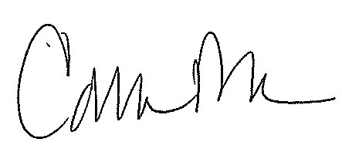
Sincerely,

Cathleen D. Bennett
President & Chief Executive Officer

