Nurse2Nurse Outreach Toolkit
W
ith nearly two-thirds of the nation’s nurses reporting that they feel overwhelmed amid COVID-19, Rutgers University Behavioral Health Care and the New Jersey Nursing Initiative, a program of the Robert Wood Johnson Foundation, have created Nurse2Nurse, a new peer support resource for nurses, by nurses. This new resource is made possible with funding from the N.J. Pandemic Relief Fund and New Jersey Nursing Initiative, a program of the Robert Wood Johnson Foundation in collaboration with the New Jersey Hospital Association.
Nurse2Nurse provides one-on-one peer support, virtual support groups, wellness webinars and a host of additional resources accessible in a variety of ways:
- Visit the Nurse2Nurse website www.nurse2nursenj.com
- Call the toll-free number, 844-687-7301, staffed by nurse peer support counselors Monday-Friday from 8 a.m. to 8 p.m.
- Request an online chat, email or return call with the form at https://nurse2nurseNJ.com/talk-to-us.
The Nurse2Nurse Outreach Toolkit is designed for nursing groups; hospitals, health systems and other healthcare employers; Human Resources professionals; Employee Assistance Programs; and other nursing stakeholders to help raise awareness of this free, confidential resource among nurses and nursing students in all settings.

Nurse2Nurse Key Messages
- Nurse2Nurse is an initiative of Rutgers University Behavioral Health Care and New Jersey Nursing Initiative created in response to the unprecedented stress and pressures nurses have faced as they respond to the COVID-19 pandemic.
- It is confidential and is not affiliated with any hospital or health system.
- Nurse2Nurse employs active and retired nurses trained in reciprocal peer support and wellness principles.
- Peer support is non-judgmental, empathic and is delivered by nurses, for nurses.
- Nurses can access the resources in a variety of ways to suit their preferences: by phone, via the Nurse2NurseNJ website, email, one-on-one chats and virtual support groups.
- Nurse2Nurse is built on a model developed by the Rutgers University National Center for Peer Support, which has successfully provided crisis counseling, peer support and disaster response support to other groups including law enforcement officers and veterans.
- It uses a holistic approach that spans physical and mental wellness, but also other dimensions of health including occupational, spiritual and social needs.
- Peer support has yielded measurable benefits including increased self-esteem and confidence, a greater sense of control, improved self-care and an increased sense of hope.
- The peer-support service is made possible with funding from New Jersey Pandemic Relief Fund, with additional funding from NJNI, a program of the Robert Wood Johnson Foundation in collaboration with the New Jersey Hospital Association.

Survey Data
In a December 2020 survey of more than 12,000 nurses across the country, the American Nurses Foundation gathered feedback on the pandemic’s impact on their physical, mental and emotional wellness. The results revealed:
- 72 percent of nurses reported being exhausted amid the pandemic
- 64 percent feel overwhelmed
- 57 percent report feelings of anxiety or irritability
- 47 percent felt sad
- 38 percent reported being depressed
- 37 percent felt isolated and lonely
- 36 percent were angry.
These impacts manifested themselves in many ways, according to the nurse respondents:
- 67 percent reported difficulty sleeping, or sleeping too much
- 40 percent reported overeating
- 25 percent reported difficulties in their relationships
- 19 percent said they had used alcohol
- 15 percent reported poor appetite.

Outreach Tools
This Nurse2Nurse Outreach Toolkit includes the following resources. They are available for download at www.njha.com/nurse-emotional-wellbeing/download-tools.
- Flier (also available at https://nurse2nursenj.com/brochures-posters/)
- Poster to use in staff areas (also available at
https://nurse2nursenj.com/brochures-posters/)
- Social media posts
- Social media graphics (JPGs attached in two sizes)
- Sample article for internal newsletters
- PowerPoint presentation (attached)

Poster
Flier
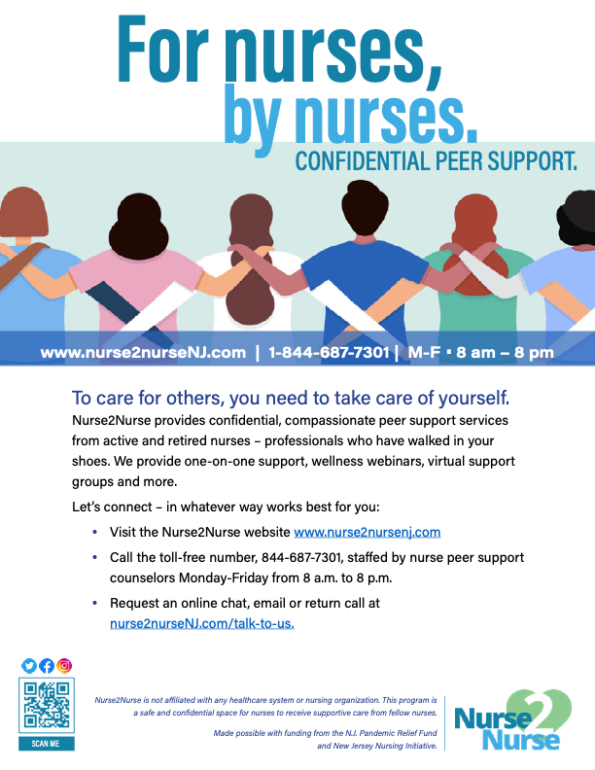

Download at https://nurse2nursenj.com/brochures-posters/

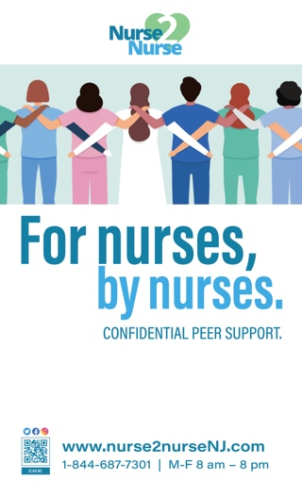
Download at https://nurse2nursenj.com/brochures-posters/

Social media graphics
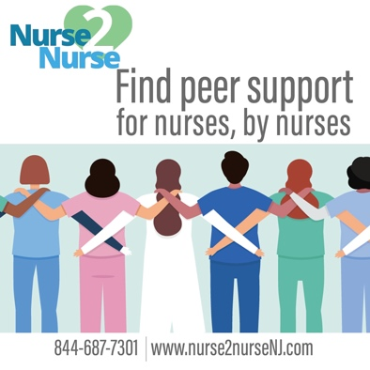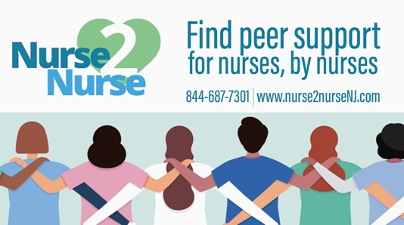
Twitter/Linked In 1200x670 pixels
FB/Instagram 1080x1080 pixels

PowerPoint presentation
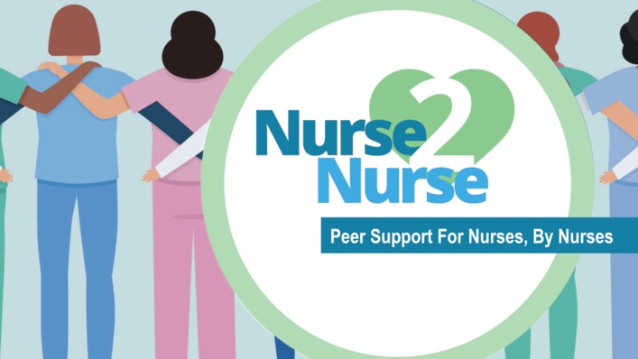

Social media sample posts
Facebook
Nearly two-thirds of the nation’s nurses say they have felt overwhelmed amid COVID-19. If you’re feeling that way too, know that you’re not alone. The #Nurse2NurseNJ helpline and web resource offers confidential, compassionate peer support for NJ nurses, staffed by active and retired nurses who have walked in your shoes. Nurse2Nurse offers one-on-one support, wellness webinars, virtual support groups and more. Nurse2Nurse is available online at www.nurse2nurseNJ.com and via its toll-free helpline 1-844-687-7301 which is staffed Monday through Friday from 8 a.m. to 8 p.m.

Are you a nurse? Thank you for always being there to care! We want to make sure you’re aware of a new resource for nurses, by nurses. The #Nurse2NurseNJ helpline and web resource offers confidential, compassionate peer support for NJ nurses, staffed by active and retired nurses who have walked in your shoes. Nurse2Nurse offers one-on-one support, wellness webinars, virtual support groups and more. Nurse2Nurse is available online at www.nurse2nurseNJ.com and via its toll-free helpline 1-844-687-7301 which is staffed Monday through Friday from 8 a.m. to 8 p.m.

Instagram
Judgment-free zone! Nurse2Nurse is a new helpline and website for nurses, by nurses. It offers peer support that is confidential, compassionate and non-judgmental provided by active and retired nurses. Visit the website at www.nurse2nursenj.com to find wellness webinars, virtual support groups and other resources, or call the helpline at 1-844-687-7301 for one-on-one support from someone who understands.
#Nurse2NurseNJ
#PeerSupport
#Nurses
#HealthcareHeroes

Nearly two-thirds of the nation’s nurses say they have felt overwhelmed amid COVID-19. If you’re feeling that way too, know that you’re not alone. The Nurse2Nurse helpline and web resource offers confidential, compassionate peer support for NJ nurses, staffed by active and retired nurses who have walked in your shoes. Nurse2Nurse offers one-on-one support, wellness webinars, virtual support groups and more. Nurse2Nurse is available online at www.nurse2nurseNJ.com and via its toll-free helpline 1-844-687-7301 which is staffed Monday through Friday from 8 a.m. to 8 p.m.
#Nurse2NurseNJ
#HealthcareHeroes
#PeerSupport
#Nurses

Twitter
Confidential, compassionate peer support for nurses, by nurses. The #Nurse2NurseNJ hotline & website provide vital resources to help nurses support their own well-being as they care for others. Visit www.nurse2nurseNJ.com or call 1-844-687-7301 M-F 8 am to 8 pm
Nurses are always there for others, now #Nurse2NurseNJ is here for them with active and retired nurses offering peer support from someone who understands. Call toll-free 1-844-687-7301 M-F 8 am to 8 pm or visit www.nurse2nurseNJ.com
The #Nurse2NurseNJ helpline is free, confidential, non-judgmental and not affiliated with any healthcare facility or nursing organization. It’s just nurses helping each other through peer support. Call toll-free 1-844-687-7301 M-F 8 am to 8 pm or visit www.nurse2nurseNJ.com
Sample internal newsletter article
Nurse2Nurse: Peer Support from Someone Who Has Walked in Your Shoes
One of the best ways to take care of your patients is to take care of yourself – body, mind and soul. Nurse2Nurse is a new resource that provides wellness resources and peer support for nurses, by nurses.
The Nurse2Nurse helpline (1-844-687-7301) and website (www.nurse2nursenj.com) provide one-on-one peer support, virtual support groups, wellness webinars and a host of free, confidential resources. Nurse2Nurse is operated by Rutgers University Behavioral Health Care and is made possible with funding from the N.J. Pandemic Relief Fund and New Jersey Nursing Initiatives, a program of the Robert Wood Johnson Foundation in collaboration with the New Jersey Hospital Association.
The pandemic has intensified the stressors of the vital work performed by nurses. Nearly two-thirds of the nation’s nurses report that they feel overwhelmed amid COVID-19, according to a survey of more than 12,000 nurses by the American Nurses Foundation.
“In order to care for others, nurses must heed their own emotional health,” said NJNI Director Susan W. Salmond, RN, executive vice dean and professor of the Rutgers School of Nursing. “Mental health matters. This emotional resiliency is required for self-compassion, compassion for peers and compassion for the patients that we take care of. Our hope, through the Nurse2Nurse helpline, is to provide empathic support to nurses from someone who has walked in their shoes.”
Nurse2Nurse uses a model developed by the Rutgers University National Center for Peer Support, which has successfully provided crisis counseling, peer support and disaster response support to other groups including law enforcement officers and veterans. It uses a holistic approach that spans physical and mental wellness, but also other dimensions of health including occupational, spiritual and social needs.
Nurse2Nurse is staffed by active and retired nurses whose shared experience links them to today’s nurses on healthcare’s frontlines. Connect with them in a variety of ways:
- Visit the Nurse2Nurse website www.nurse2nursenj.com
- Call the toll-free number, 844-687-7301, staffed by nurse peer support counselors Monday-Friday
from 8 a.m. to 8 p.m.
- Request an online chat, email or return call at https://nurse2nurseNJ.com/talk-to-us

